Data percobaan

|  |  |  |  |  |  |
| --- | --- | --- | --- | --- | --- |
| No | Suhu sebenarnya  (ºC) | Suhu terukur  (ºC) | Eror | %Eror | %Akurasi |
| 1. | 32 | 30.76 | 1.24 | 3.8 | 96.2 |
| 2. | 36.7 | 36.6 | 0.1 | 0.2 | 99.8 |
| 3. | 41.9 | 38.1 | 3.8 | 9.06 | 90.94 |
| 4. | 45.4 | 44.8 | 0.6 | 1.3 | 98,7 |
| 5. | 52.3 | 52.2 | 0.1 | 0.19 | 99.81 |
| 6. | 55 | 55.7 | 0.7 | 1.27 | 98.73 |
| 7. | 60.3 | 61.2 | 0.9 | 1.5 | 98.5 |
| 8. | 66.2 | 65.5 | 0.7 | 1.06 | 98.94 |
| 9. | 71.4 | 70.2 | 1.2 | 1.6 | 98.4 |
| 10. | 78.5 | 78.6 | 0.1 | 0.1 | 99.9 |

Bikin frizzing dan proteus

Data nomor 1

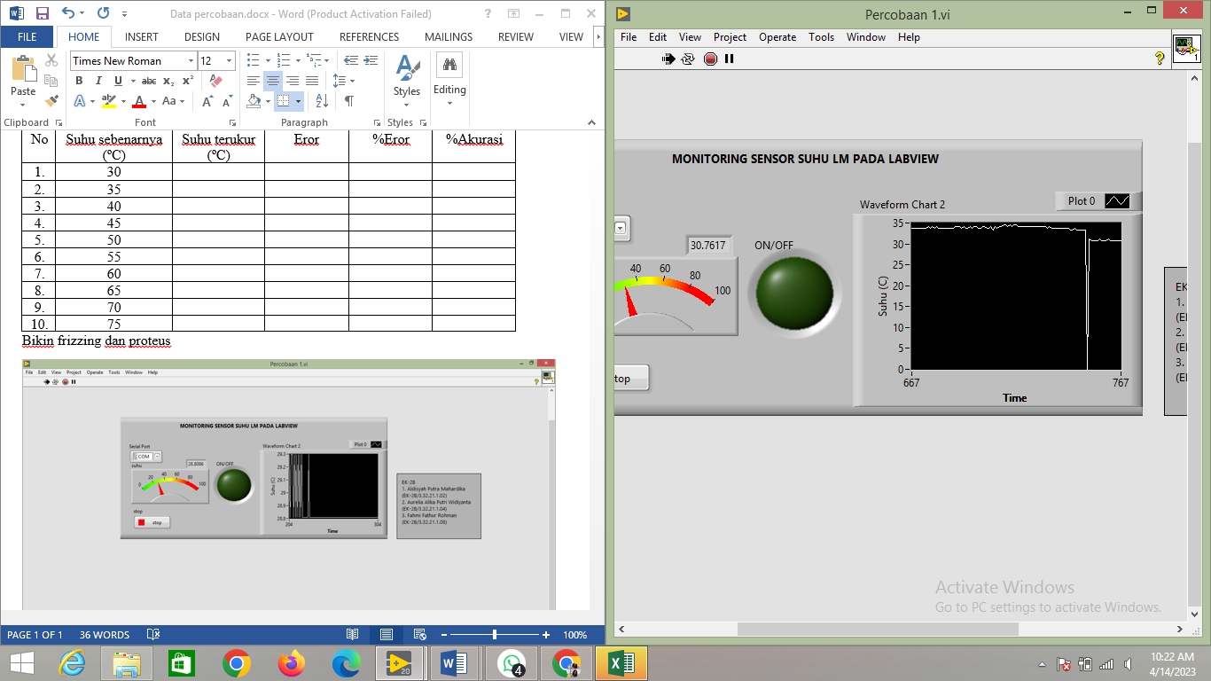 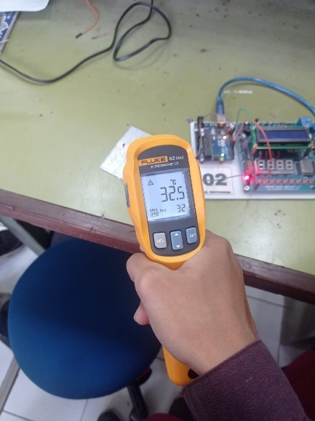

Data nomor 2

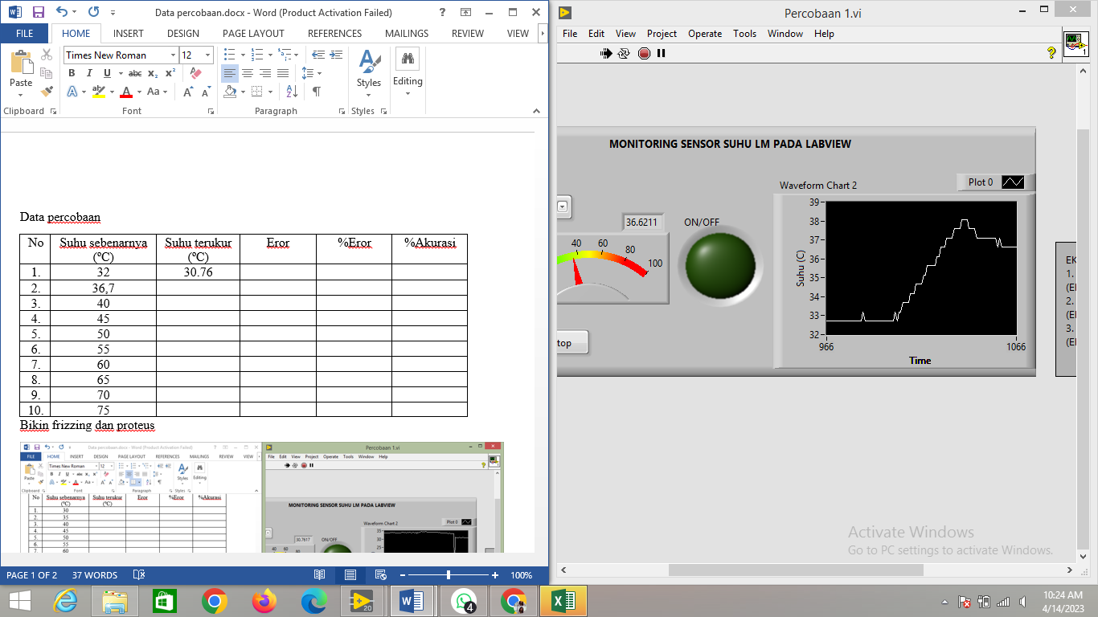 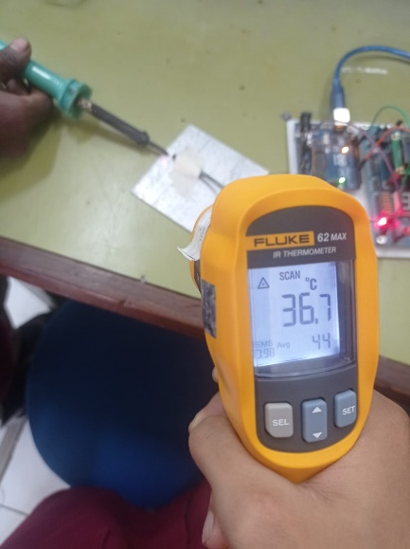

Data nomor 5

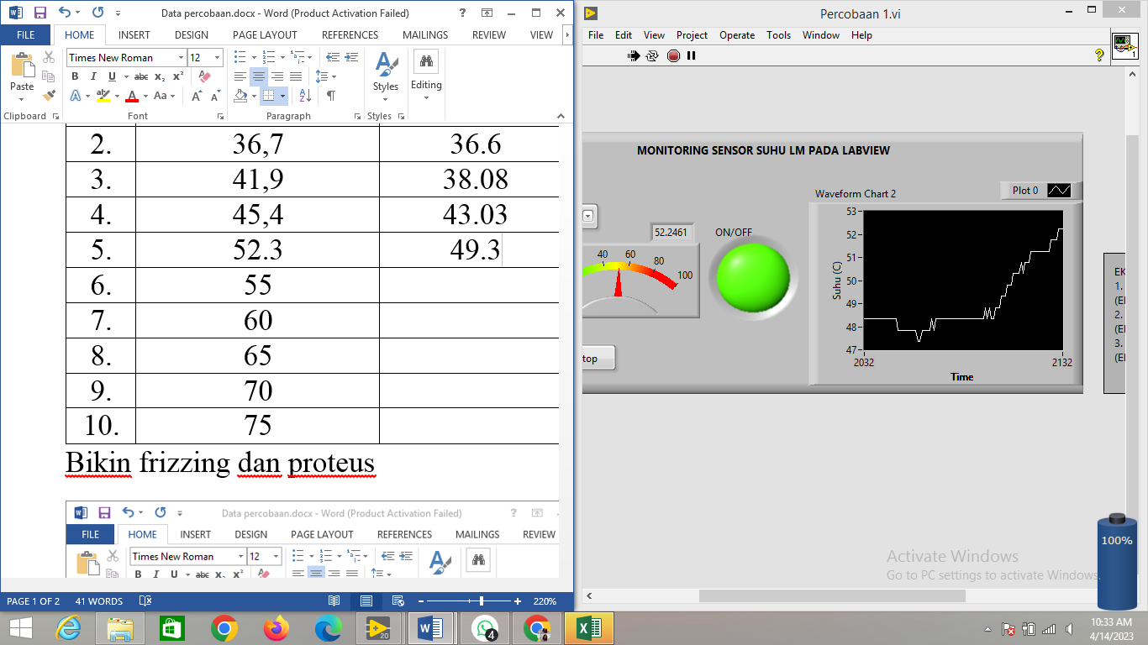 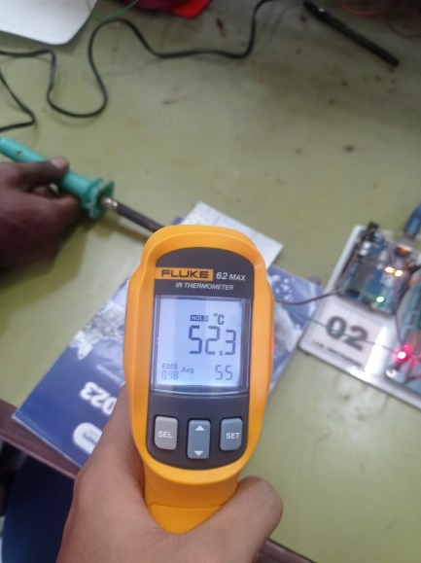

Data nomor 10

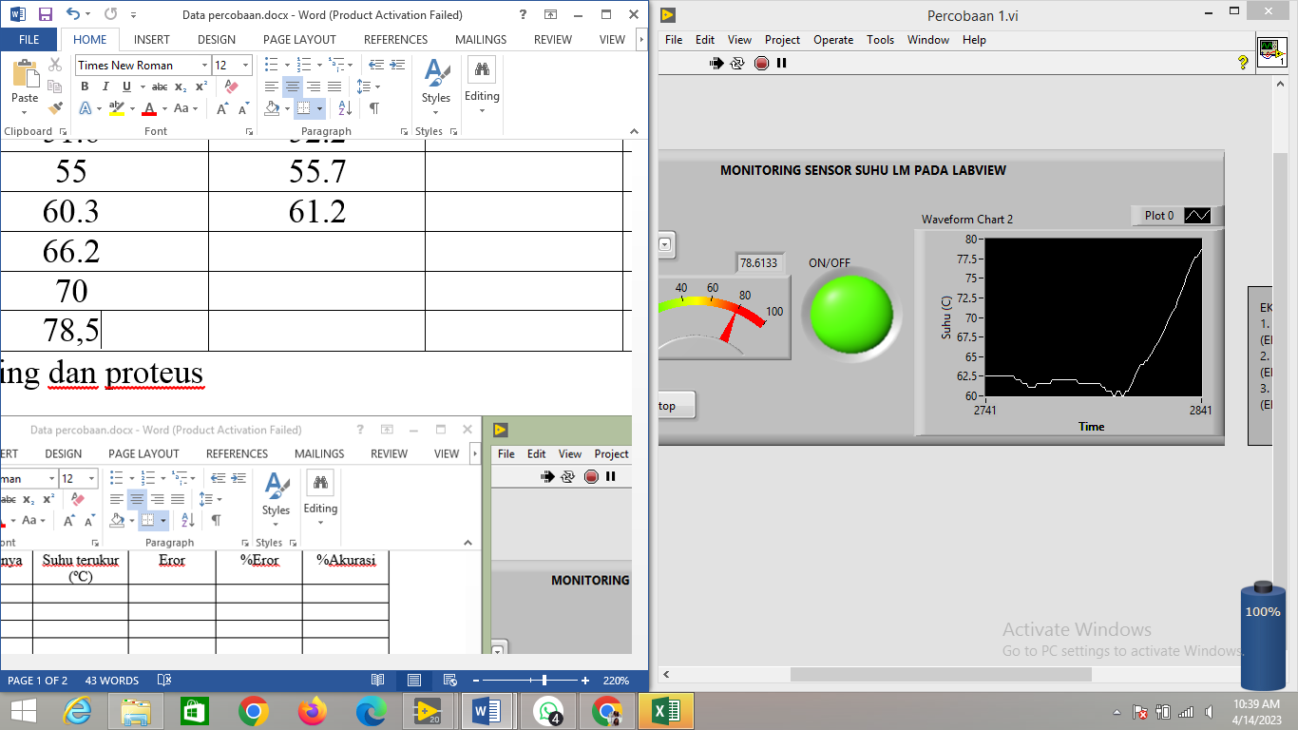 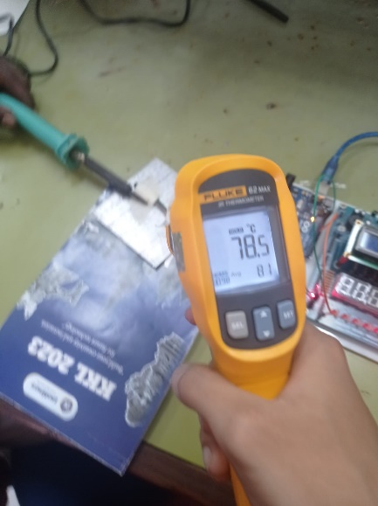

Fritzing Proteus

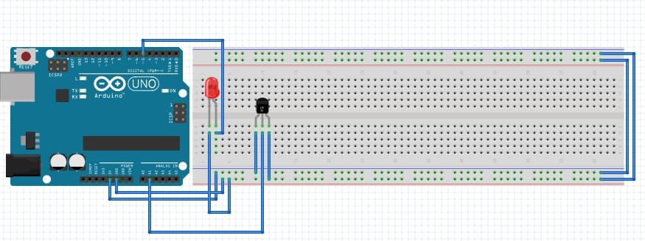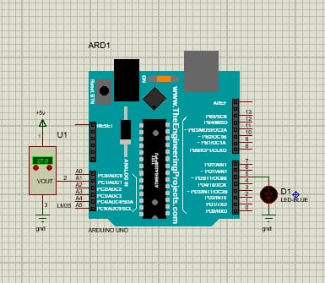

Keadan lampu saat suhu diatas 50

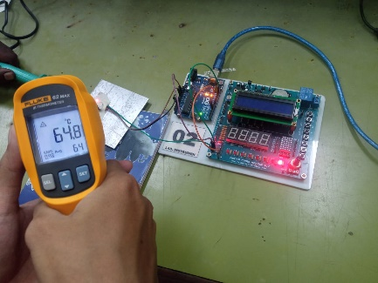

Suhu dibawah 35

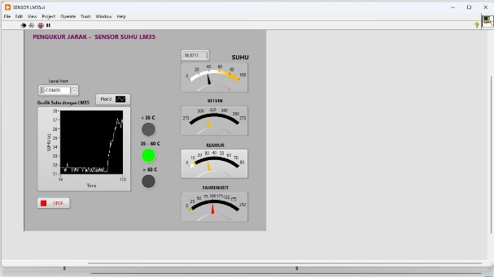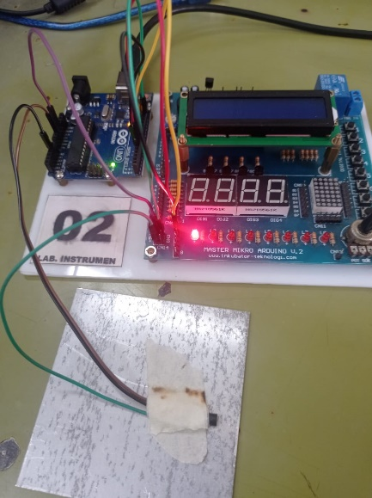

Suhu diatas 35 dan dibawah 60

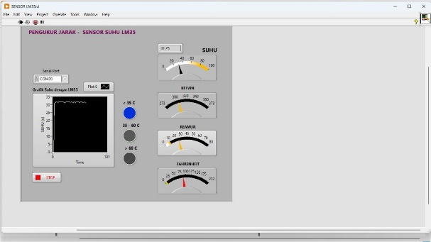 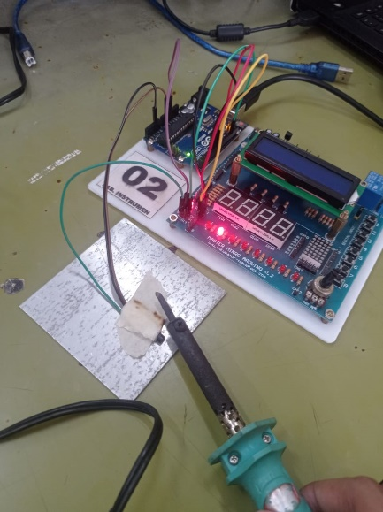

Suhu diatas 60

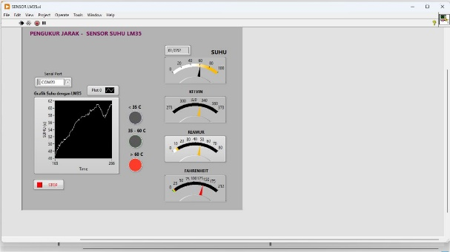 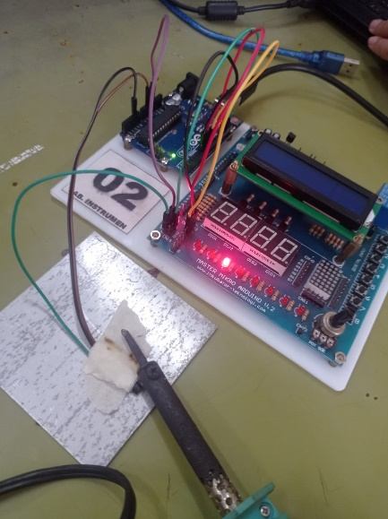

Fritzing Proteus

